Situational Awareness – Wheeled Sports
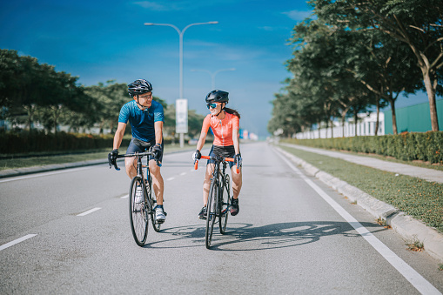
SUMMARY
What is Situational Awareness (SA) and why do we need to understand and use it.
GENERAL INFORMATION
Situational Awareness is keeping your head on a swivel – or paying attention to your constantly changing surroundings.
You need to be checking your surroundings all the time for any changes or dangers that may develop with no warning. Maintain in your head what you see and integrate that with the other information you are gathering and use it to be aware.
Checking around you will allow you to avoid most of the potential hazards that may find their way to interrupt your day.
Example: While riding your bicycle on a bike path a few feet away from the main road, you see out of the corner of your eye a car that appears to start a right turn just in front of you.
This awareness of your surroundings allows you to prepare to deal with this car – ride the brakes or place your hands on the brakes without using them, slow down, or stop.
If you are not paying attention – you may hit the car as it turns or worse, get hit by the car.

No matter what activity you are doing, you need to be on alert for any safety issue that could ruin your whole day.
Other examples include:
Planning the activity – route, hazards, breaks, weather forecast, distance, and physical abilities of all
Weather hazards – to include heat and cold, rain and wind.
Bike Safety – Proper maintenance avoids issues later
Medical issues – hydration, sunscreen, food
Clothing – High Visible shirt or vest, helmet, gloves, special shoes, and clothing for hot or cold rides

RESOURCES
- Guide to Safe Scouting – Weather Training
- Scouting Safely
- Program Hazard Analysis
- Enterprise Risk Analysis Tool
- Event Safety Checklist
- Campout Safety Checklist
- Safety PAUSE
- Enterprise Risk Management Committee Guidebook

