1
21
81
71
61
51
41
31

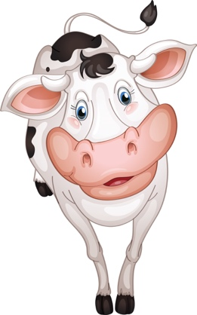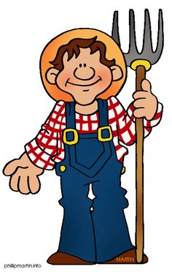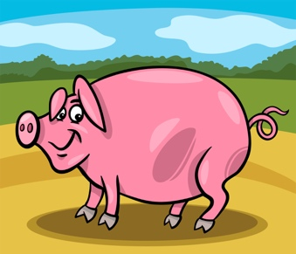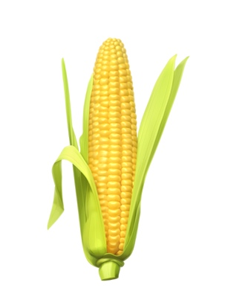

COW

PIGS
CORN

FARMER

HORSE

PLOW
HAY
TRACTOR

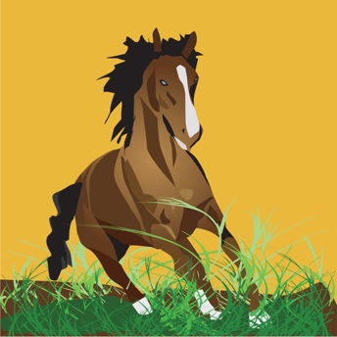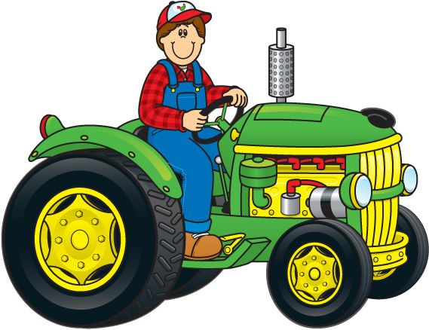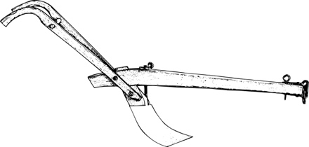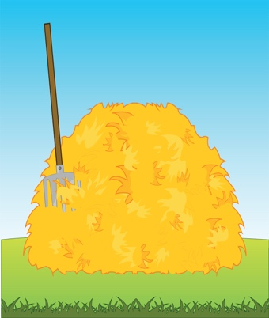
PIGS

Pigs have forty-four teeth.

A pigs tail can be straight, kinked or curly.

Pigs are warm blooded.

Pigs grunt to communicate with each other.

Pigs roll in the mud because it protects their skin from sunburn.

Baby pigs are called piglets.

FARMER

Farmer is someone who owns land and farms it.

They grow a variety of crops depending on their climate.

Some farmers have livestock.

On a family farm – everyone must lend a hand.

Today a farm can grow enough food to feed as many as 100 people.
HORSE

Horses have the largest eyes of any land mammal.

A horse’s teeth take up a larger amount of space in their head than their brain.

Horses hooves are made from the same protein that comprises human hair and fingernails.

Horses are capable of seeing nearly 360 degrees at one time.

COW

Estimated 1.3 billion head of cattle and 920 breads.

They produce most of the milk that people drink.

Group of cows is a herd.

A cow spends up to 6 hours a day chewing their cud.

They never forget their calves.

The Holstein cow produces the most milk.

TRACTOR

A tractor is a strong work vehicle used for farming.

Usually has a seat for only the driver.

The tractor can pull many different tools or trailers.

Tractors can pull heavy or light loads.

Tractors have link arms on the front and the back.
PLOW

A plow is a simple machine used in farming.

It is pulled by either an animal or a human.

The plow lifts up dirt and makes two lines of dirt behind it.

Ground that has been plowed is a good place for a farmer to grow food.

CORN

Corn is a cereal crop that is part of the grass family.

Corn will always have an even number of rows on each cob.

On average, an ear of corn has 800 kernels in 16 rows.

There are over 3,500 different uses for corn products.

Corn can be produced in various colors.

HAY

Hay is grass and other plants that have been cut, dried and collected.

It is stored in piles called hay stacks or tied into blocks called bales.

Bales can be round or box shaped.

Hay is mostly used to feed animals.

Hay is good winter feed.

